# Tables vs. Views - Solution

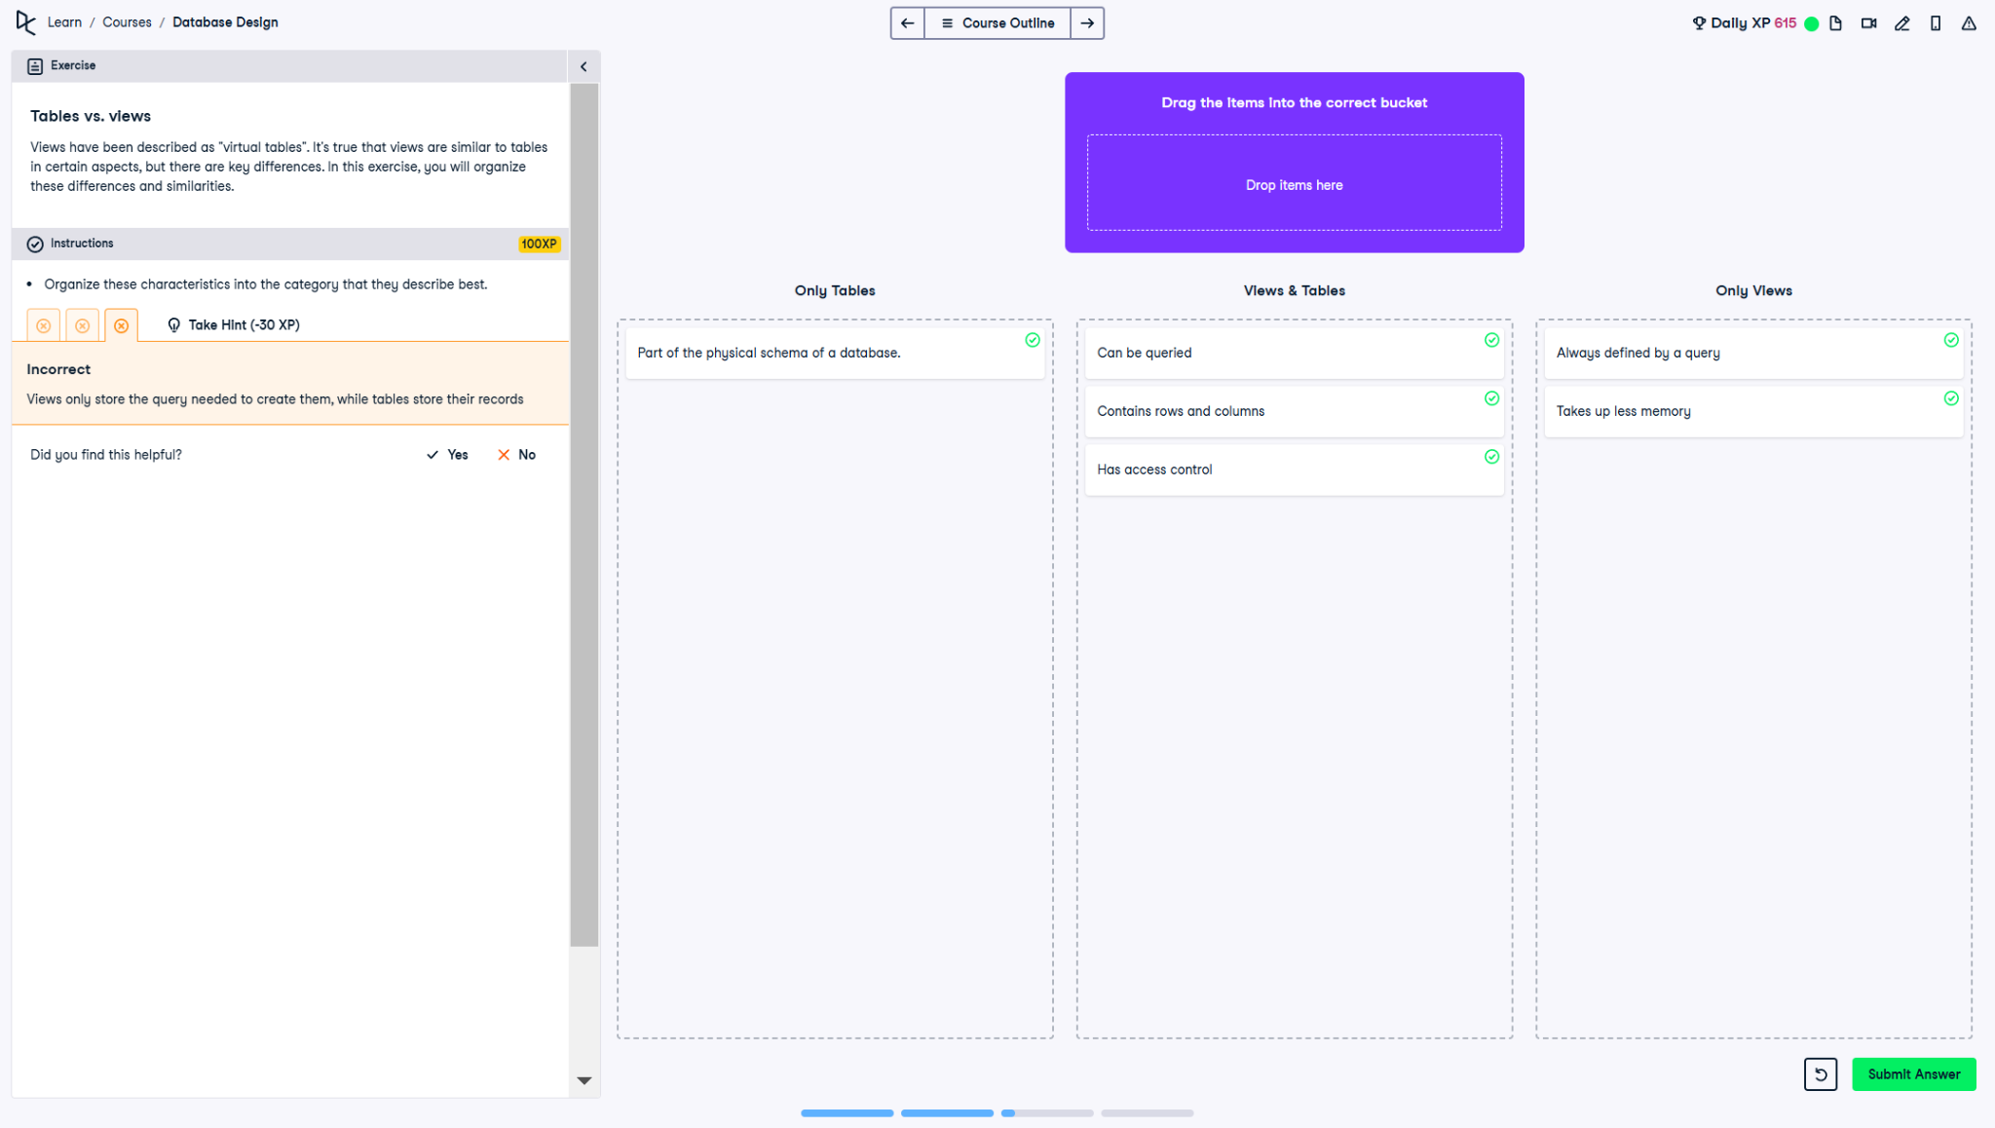

## Question

Views have been described as 'virtual tables'. It’s true that views are similar to tables in certain aspects, but there are key differences. In this exercise, you will organize these differences and similarities.

## Correct Classification

### ✅ Only Tables:

• Part of the physical schema of a database.

### ✅ Views & Tables:

• Can be queried.

• Contains rows and columns.

• Has access control.

### ✅ Only Views:

• Always defined by a query.

• Takes up less memory.

## Answer Explanation

1. **Only Tables:**  
 - Tables are **physically stored** in the database.  
 - They are part of the **physical schema**, meaning they hold **persistent data**.  
  
2. **Views & Tables:**  
 - Both **can be queried** using SQL.  
 - They **contain rows and columns**, just like traditional tables.  
 - Both **support access control**, allowing permissions to be granted.  
  
3. **Only Views:**  
 - Views are **always defined by a query**, meaning they do **not store data directly**.  
 - Views take up **less memory**, as they **only store query definitions**, not actual data.